**Excel Assignment – 7**

**Q1: Using Insert Function, give examples of any function available in the different dropdowns resent in the function library. For example AutoSum, Recently Used, Text, Date & Time, etc.**

Ans: 1. Date and time include functions like week , month , year , today , day hour , minute etc.

2. Text category include functions like upper , lower , value , replace , fix etc.

3. Math and trig include functions are sum , average , sort , abs , subtotal , sin , cos

**Q2: What are the different ways you can select columns and rows?**

Ans: 1. To select column : **Ctrl + Shift + down** key Or **Shift +ctrl+up**

2. To select row : **Shift + space**

**Q3: What is AutoFit and why do we use it?**

Ans: **AutoFit** is a feature in Excel that allows you to quickly adjust the row height or column width to fit the text completely. We use autofit because it will automatically adjust the row height to fit the text in the cell .

**Q4: How can you insert new rows and columns into the existing table?**

Ans: At home tab go to insert section , where if we want to add row then choose ‘Insert sheet Rows’ then it will add row to upward side and if we want to add column then we need to choose ‘Insert Sheet Columns’ then it will add column to the left side.

**Q5: How do you hide and unhide columns in excel?**

Ans: To hide the column , click on that column , right click and choose hide .

To unhide the column , select the hide column and right click then choose unhide .

Or

Go to home tab , choose format section then opt the hide and unhide option we can see the

Dropdown which contain hide row , unhide rows , unhide columns , hide columns .

**Q6** **Create an appropriate table within the worksheet and use different functions available in the AutoSum command.**

Ans:

Calculate minimum value : go to format and click on min and press enter

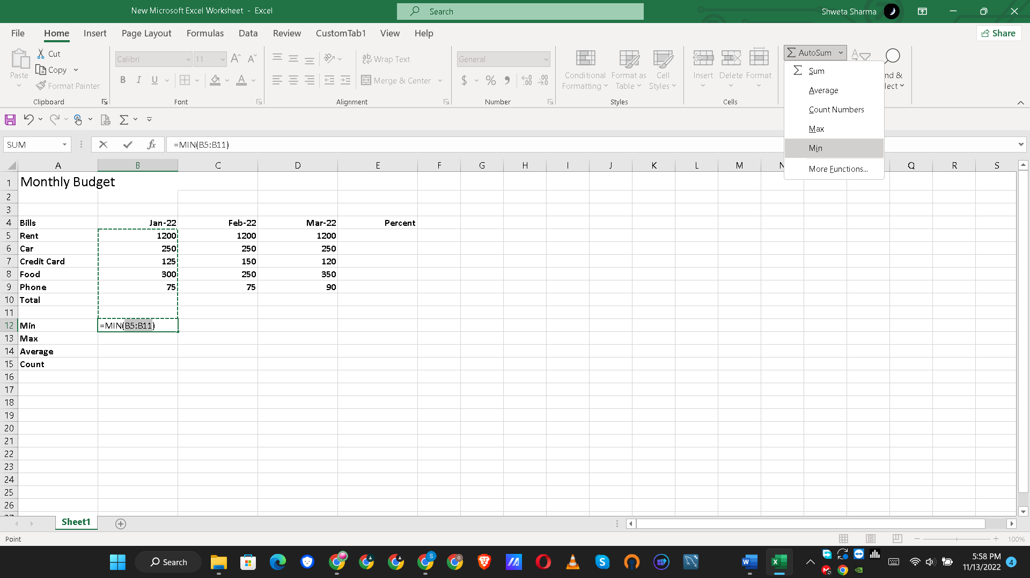

Then to calclaute feb and mach minimum value , drag the B12 cell upto D12 .

2. Calculate max value :

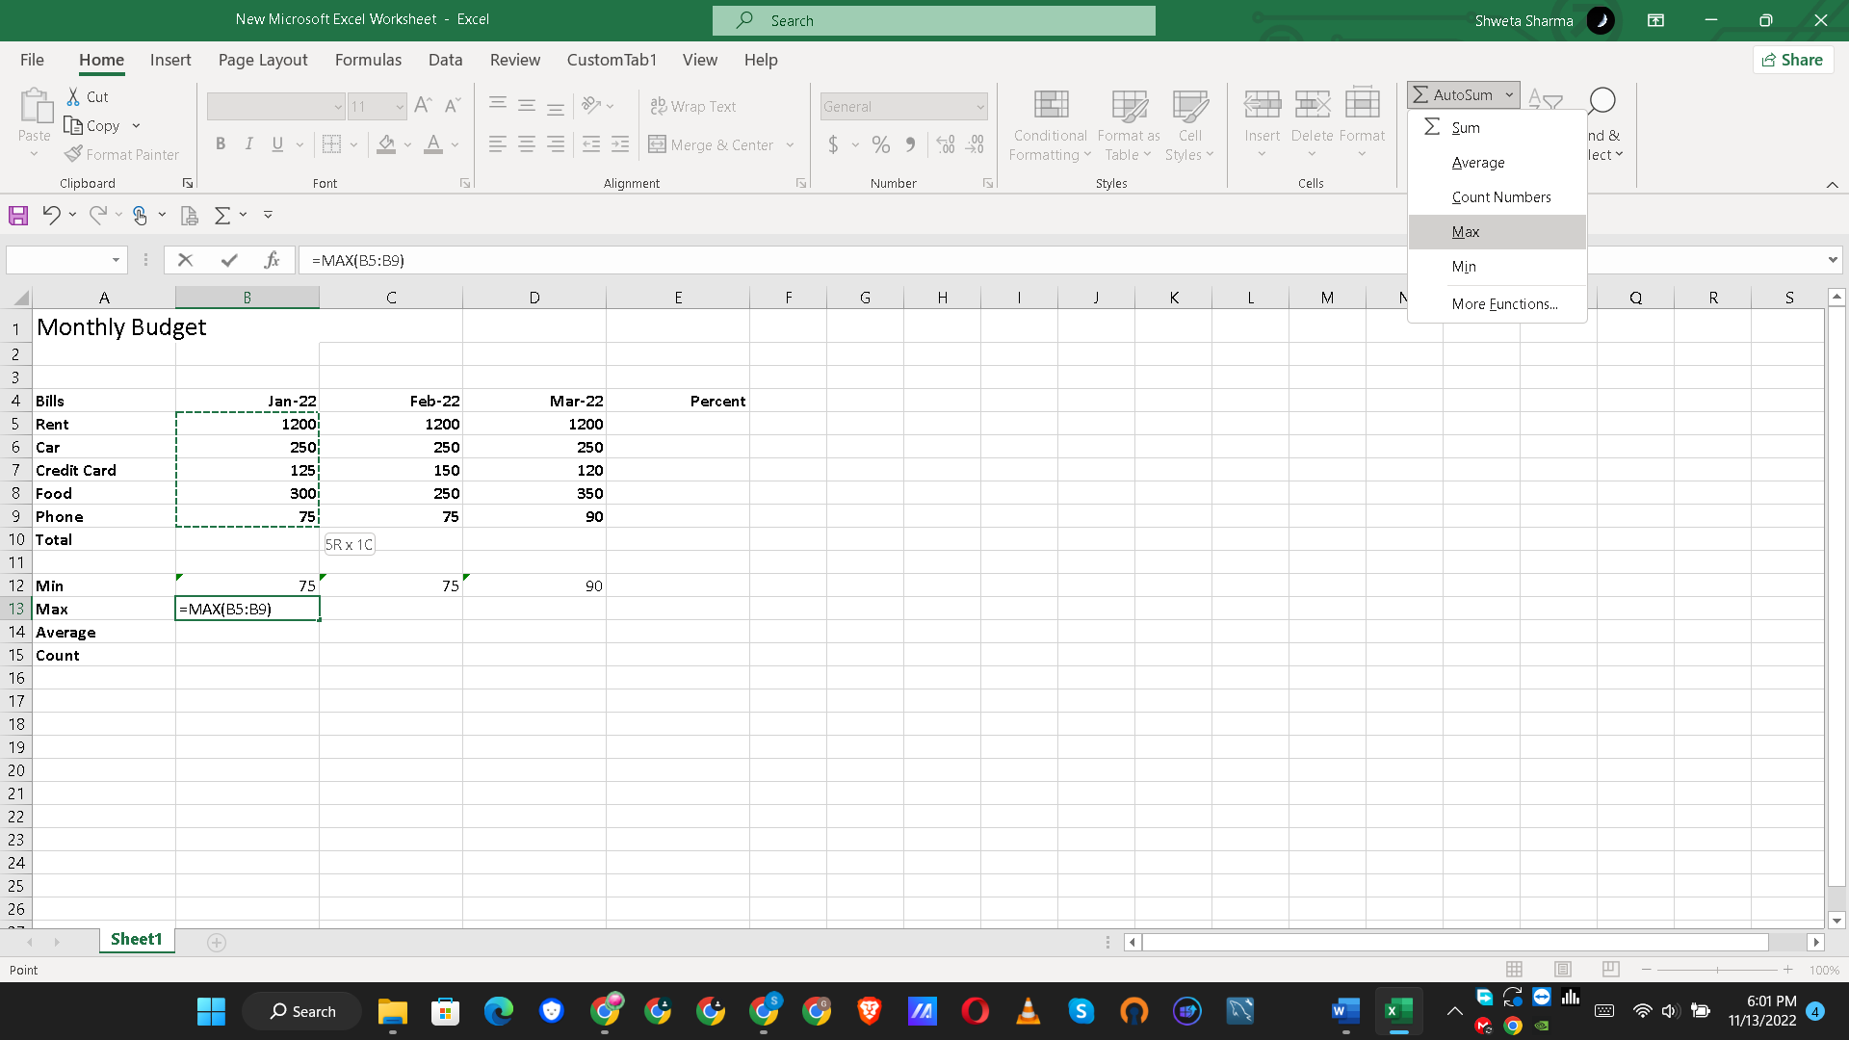

3. Calculate Average value : select column which you want to get average .

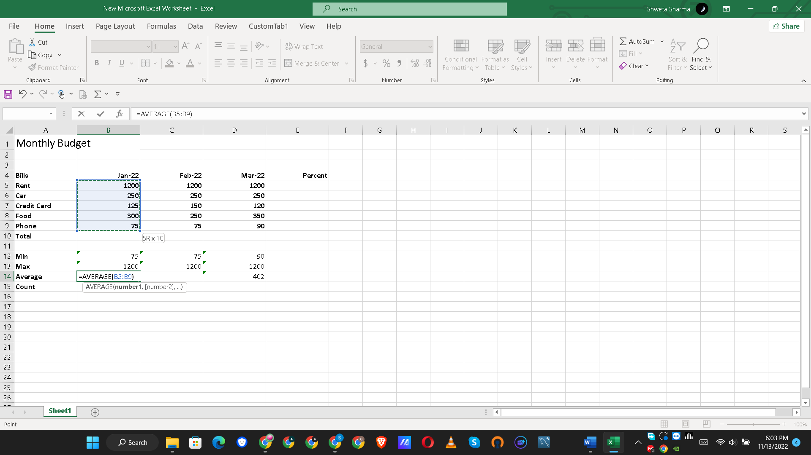

4. Count Numbers :

